 |  | Substation |  |  | JALAN ROBINSON |  |  |  |  |  |  |  |  |  |  |  |  | Date: 01/06/2026
 |  | Equipment |  |  | TRANSFORMER |  | Manufacturer |  |  |  |  |  |  |  |  | MTM |  | Time: 4:02 PM
 |  | Model |  |  | HERMETICALLY SEAL |  | Rating |  |  |  |  |  |  |  |  | 100kVA |  | Humidity: 77%
 |  | Area |  |  | OVERVIEW |  |  |  |  |  |  |  |  |  |  | Tx No. |  | 1
Location
 | IR IMAGE |  |  |  |  |  |  |  |  |  |  | VISUAL IMAGE
 |  |  |  |  |  |  |  |  |  |  |  | 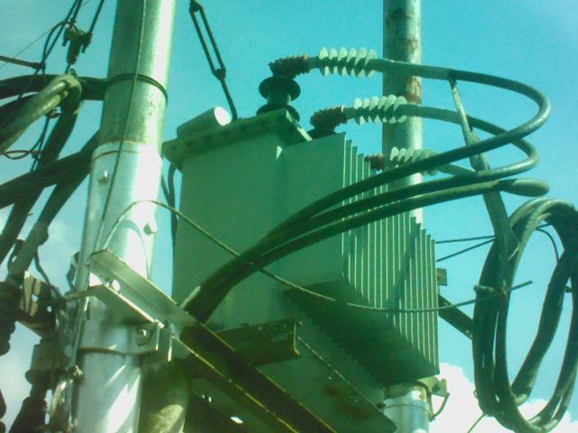
 | PARAMETER |  | VALUE
 | Spot Temp.1 (Sp1) |  | 40.4 °C |  |  |  |  |  |  |  |  |  |  |  | PARAMETER |  |  | VALUE
 | Spot Temp. 2 (Sp2) |  | 37.2 °C |  |  |  |  |  |  |  |  |  |  |  | Serial No. |  |  | T/800/1452/1486
 | Average Temp. (Ar1) |  | 36.7 °C |  |  |  |  |  |  |  |  |  |  |  | Heater (A) |  |  | -
 | Ambient Temp. |  | 23.2 °C |  |  |  |  |  |  |  |  |  |  |  | CB Position |  |  | -
 | Delta T ( ∆ T) |  | 3.2 °C |  |  |  |  |  |  |  |  |  |  |  | Busbar Position |  |  | -
 | Load (A) |  | - |  |  |  |  |  |  |  |  |  |  |  | Cable Type |  |  | -
 | Defect |  | -
 | ULTRASOUND IMAGE
 | 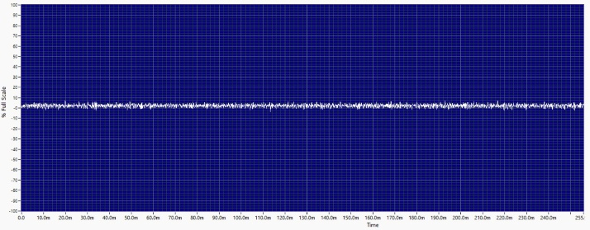
 | Decibel (dB) |  |  | -
 | Sound characteristic |  |  | -
 | Defect |  |  | -
 | Sound clip |  |  | 

Analysis & Recommendations:
Analysis: No Anomaly.
Recommendation: -

